SOFTWARE PRACTICALS

RAPTOR PROGRAMS

1.FIBONACCI SERIES

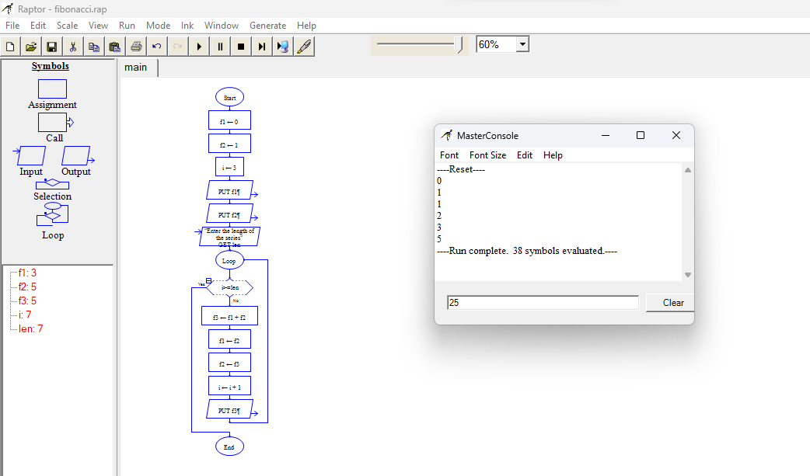

2.NUMBERS FROM 1 TO 10

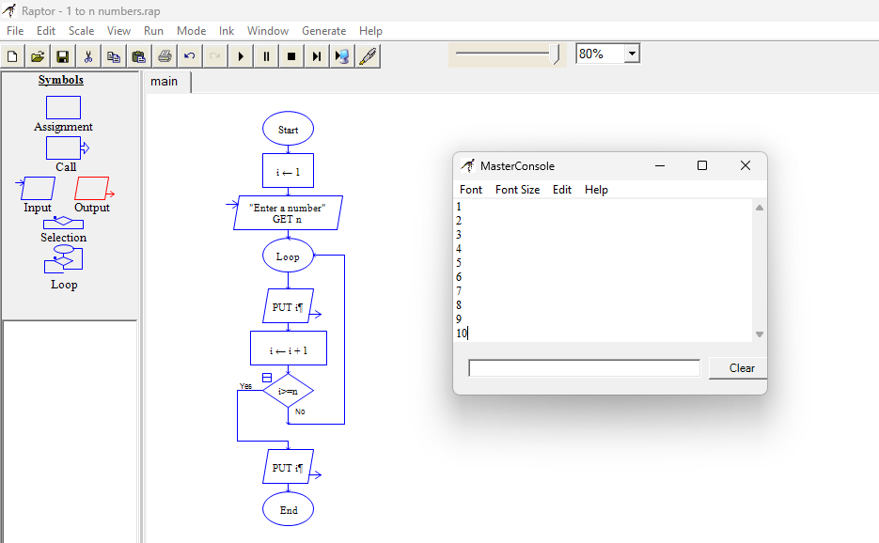

3.NUMBER OF CHARACTERS IN A STRING

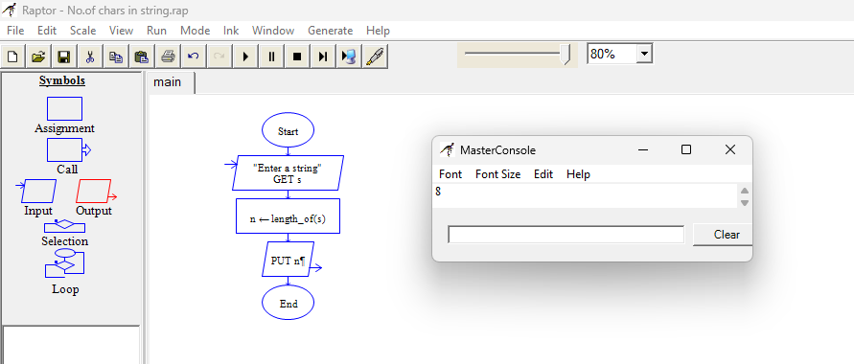

4.REVERSE OF THE STRING

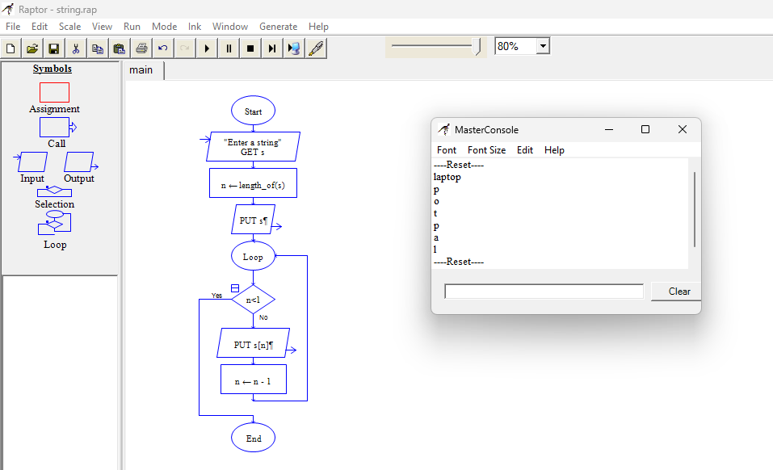

5.PRIME NUMBERS

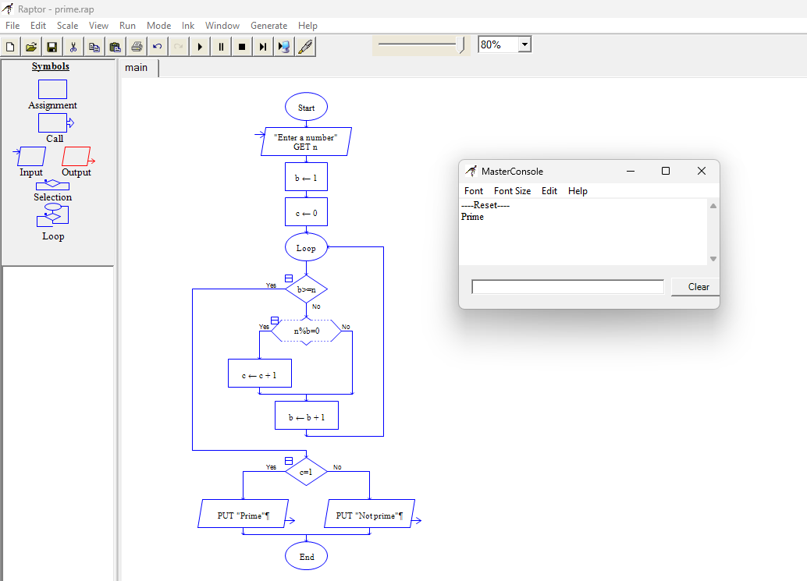

6.ALPHABETS

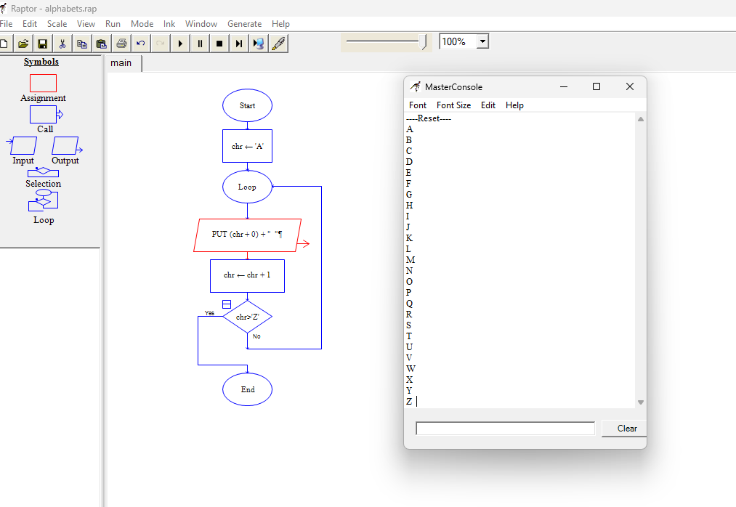

7.FACTORIAL

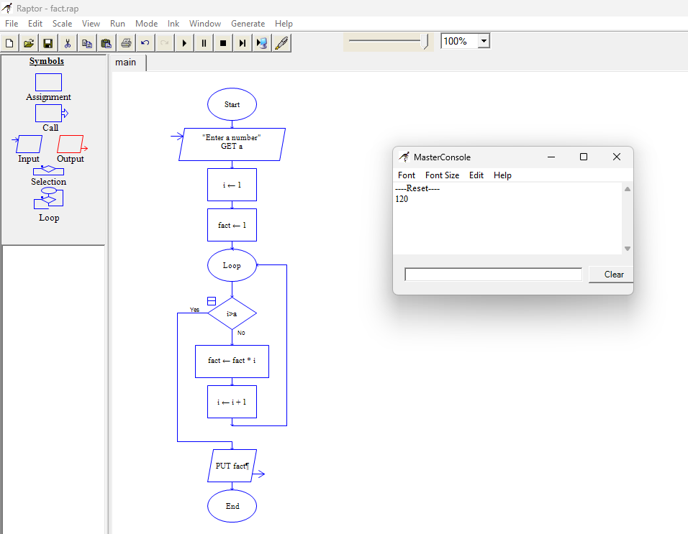

8.PALINDROME

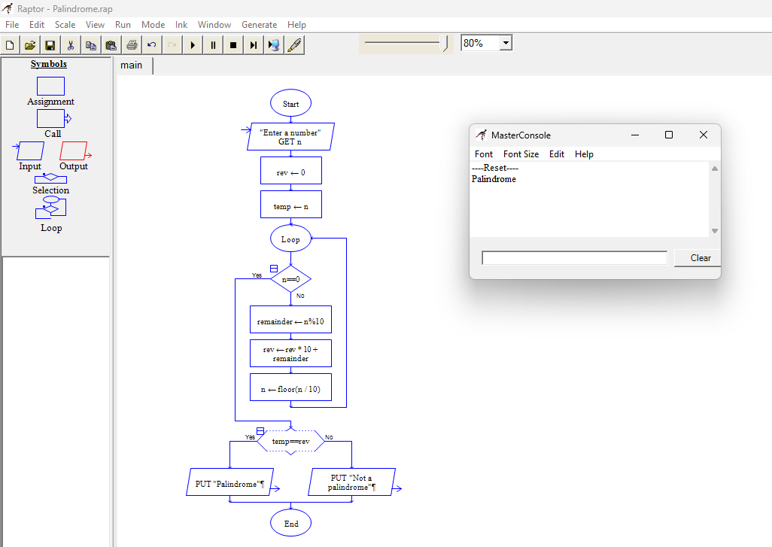

9.BIGGEST VALUE

